**West, Rebecca (1892- 1983)**

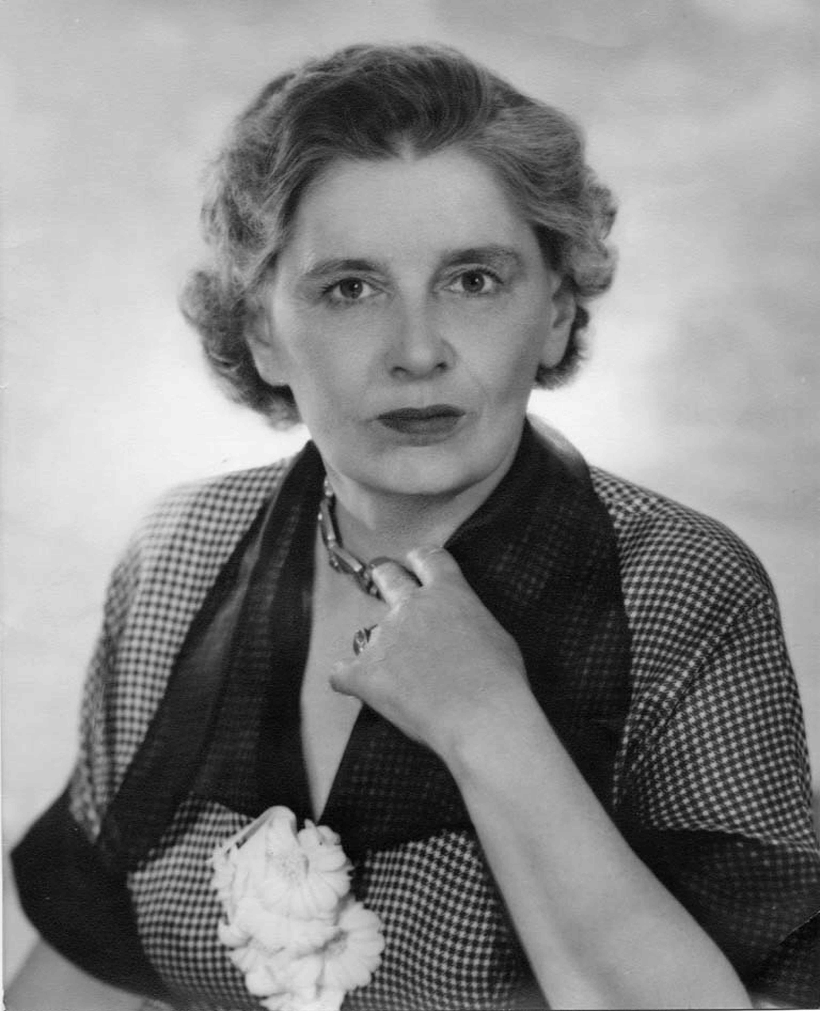SUMMARY

Rebecca West

url: <http://commons.wikimedia.org/wiki/File:Rebecca_West.jpg>

Rebecca West was a novelist, journalist, essayist and travel-writer, and a central figure in twentieth century literary and political culture. Her *The Return of the Soldier* (1918) was the first World War One novel to be written by a woman. She was in her lifetime particularly celebrated for her travel writing, notably *Black Lamb and Grey Falcon* (1941), and her coverage of the Nuremberg trials for *The New Yorker*, published as *A Train of Powder* in 1955. *Time* magazine called her ‘indisputably the world's number one woman writer’ in 1947.

MAIN ENTRY

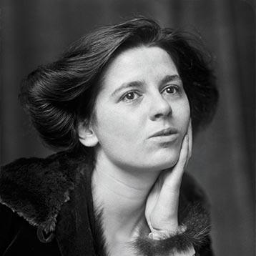Abandoned by their father when she was eight years old, Rebecca West and her two older sisters were brought up by their mother in London and Edinburgh. Her political interests were evident from a young age; her first publication was a letter written to *The Scotsman* when she was just 14, defending the suffragist National Women’s Social and Political Union. In young adulthood she supported herself through her journalism while training as an actress, taking the nom de plume Rebecca West from the freethinking heroine of HENRIK IBSEN’s *Rosmersholm* (although she later distanced herself from both the play and the character). VIRGINIA WOOLF notes in *A Room of One’s Own* (1929) that West was labelled an ‘arrant feminist’; West had famously averred in her 1913 essay ‘Mr. Chesterton in Hysterics’ that ‘I myself have never been able to find out what feminism is; I only know that people call me a feminist whenever I express sentiments that differentiate me from a doormat or a prostitute.’ She became assistant editor of the suffragist publication *The Freewoman* in 1914, playing a key role in its transformation into *The Egoist*, one of the foremost outlets for avant-garde literature and literary criticism in the period.

Rebecca West as a young woman

url: <http://www.tnr.com/book/reviews/biography>

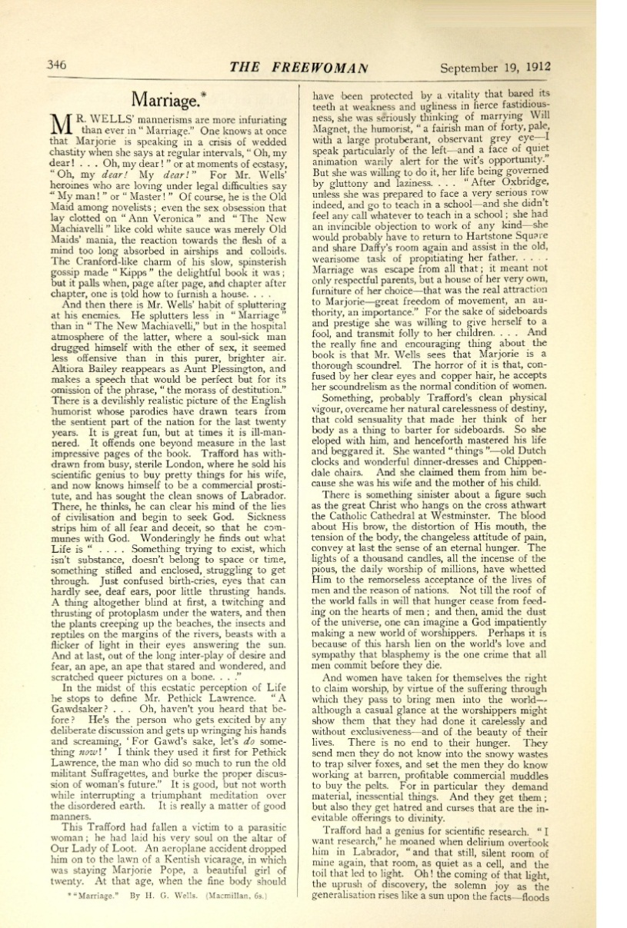

The first page of West’s controversial 1912 review of H. G. Wells’s novel *Marriage,* in *The Freewoman*. Wells was so provoked that he invited West to lunch; they began an affair that was to last a decade.

url: <http://dl.lib.brown.edu/pdfs/1302281169451379.pdf>

This item might be better as a pop-out so that it can be large enough for the type to be legible.

*The Return of the Soldier* was her first novel, written when she was 24 and published when she was 26. While with less explicit political heft than some of her other work, it nevertheless carries a powerful indictment of war, in particular its effect on the women of the home front, telling the story of a shell-shocked officer returning from the war. This and her two subsequent novels have recognisably modernist characteristics and preoccupations, including further explorations of Freudian themes and sexual relations, and experimentation with narrative perspective and form. She later embarked on a series of semi-autobiographical novels known as the Aubrey trilogy, although only the first of these was published during her lifetime. She was also a significant literary critic, writing a monograph on Henry James in 1916 and contributing hundreds of reviews and literary critical essays to newspapers and periodicals throughout her career.

Aside from *Black Lamb and Grey Falcon*, West’s most extensive travel writing was about her long stays in Mexico in 1966 and 1969, although again this work was only published after her death. She was an avid traveller throughout her life and was particularly fascinated by the United States, building a reputation on both sides of the Atlantic. In 1948 she was awarded the Women’s Press Club Award for Journalism by President Harry Truman, who called her ‘the world’s best reporter’. She remained intensely politically engaged throughout her life, visiting South Africa to report on apartheid for the *Sunday Times* in 1960; and continued publishing right up until her death in 1983.

**‘Goodness Doesn’t Just Happen’; West’s 1952 contribution to *This I Believe*, a regular 5-minute CBS radio feature.**

url: <http://thisibelieve.org/essay/17089/> I have been unable to download the audio file for this, though it can be purchased from Amazon, but it is freely available on the website given.

### Selected list of works

**Fiction**

*The Return of the Soldier* (1918)

*The Judge* (1922)

*Harriet Hume* (1929)

*The Harsh Voice: Four Short Novels* (1935)

*The Fountain Overflows* (1956)

*This Real Night* (1984)

*Cousin Rosamund* (1985)

**Non-fiction**

*Henry James* (1916)

*The Strange Necessity: Essays and Reviews* (1928)

*St. Augustine* (1933), first psycho-biography of the Christian Church Father

*Black Lamb and Grey Falcon* (1941)

*The Meaning of Treason* (1949)

*A Train of Powder* (1955)

*The Court and the Castle: some treatments of a recurring theme* (1958)

*1900* (1982)

*Survivors in Mexico* (2003)

### Further reading

Glendinning*,* Victoria (1987) *Rebecca West: A Life*, London: Weidenfeld & Nicolson

Norton*,* Ann V. (2000) *Paradoxical Feminism: The Novels of Rebecca West*, Bethesda, MD: International Scholars Publications.

Rollyson,Carl (1998) *The Literary Legacy of Rebecca West*, Bethesda, MD: International Scholars Publications.

Schweizer, Bernard (ed) (2006) *Rebecca West Today: Contemporary Critical Approaches,* Newark, DE: University of Delaware Press.

Wolfe, Peter (1971) *Rebecca West: Artist and Thinker,* Carbondale: Southern Illinois University Press.

**Bryony Randall, University of Glasgow**